**MCU Timer**

Sayantan Kundu (sxk210048)

**Task :** To get a square wave with 50% duty cycle with all the 3 output modes each of two continuous mode.

**Steps :**

* To get the square waveform we had to manipulate the value of “COUNT” and “COUNT2” which corresponds to “TIMER_A0->CCR[0]” and

“TIMER_A0->CCR[2]” respectively.

* We set the values of COUNT as 32768/10 and COUNT2 as 32768/20.
* We changed the variable

“TIMER_A0->CCTL[2] = TIMER_A_CCTLN_OUTMOD_x” by replacing x with 2,4,7 depending upon the output mode we need.

2 -> Toggle/Reset

4 -> Toggle

7 -> Reset

* The variable “TIMER_A0->CTL = ( x | ACLK)” was modified according to the requirements. X was replaced by “UP” and “UPDOWN” for different counting modes.

**Code for output mode 2 with UP mode**

//FOR Timer_A0

#define UP 0x0010

#define UPDOWN 0x0030

#define CONT 0x0020

#define HALT 0x0000

//32kHz ACLK (32768)

#define ACLK 0x0100

#define COUNT 32768/5

#define COUNT2 32768/10

void setup() {

WDT_A->CTL = WDT_A_CTL_PW | WDT_A_CTL_HOLD; // stop watchdog timer

myScreen.begin();

myScreen.setPenSolid(true);

pinMode(74, INPUT_PULLUP); ////74 -> P1.4 pushbotton

pinMode(34, INPUT_PULLUP);////34 -> p2_3

////********** please modify the following code ***********////

////setting up timer_A0 connected to ACLK in UP mode(counting modes)

TIMER_A0->CTL = (UP | ACLK);

TIMER_A0->CCR[0] = COUNT;

////setting up P2.5 as output mode.

P2->DIR = BIT5;

////setting up P2.5 connected to timer0.

P2->SEL0 |= BIT5;

P2->SEL1 &= ~(BIT5);

////setting up timer output mode as toggle(mode 3) (connected to P2.5)

TIMER_A0->CCTL[2] = TIMER_A_CCTLN_OUTMOD_2

;

////setting up duty cycle (connected to P2.5)

TIMER_A0->CCR[2] = COUNT2;

////********** please modify the above code ***********////

}

**Code for output mode 4 with UP mode**

//FOR Timer_A0

#define UP 0x0010

#define UPDOWN 0x0030

#define CONT 0x0020

#define HALT 0x0000

//32kHz ACLK (32768)

#define ACLK 0x0100

#define COUNT 32768/5/2

#define COUNT2 32768/10/2

void setup() {

WDT_A->CTL = WDT_A_CTL_PW | WDT_A_CTL_HOLD; // stop watchdog timer

myScreen.begin();

myScreen.setPenSolid(true);

pinMode(74, INPUT_PULLUP); ////74 -> P1.4 pushbotton

pinMode(34, INPUT_PULLUP);////34 -> p2_3

////********** please modify the following code ***********////

////setting up timer_A0 connected to ACLK in UP mode(counting modes)

TIMER_A0->CTL = (UP | ACLK);

TIMER_A0->CCR[0] = COUNT;

////setting up P2.5 as output mode.

P2->DIR = BIT5;

////setting up P2.5 connected to timer0.

P2->SEL0 |= BIT5;

P2->SEL1 &= ~(BIT5);

////setting up timer output mode as toggle(mode 3) (connected to P2.5)

TIMER_A0->CCTL[2] = TIMER_A_CCTLN_OUTMOD_4

;

////setting up duty cycle (connected to P2.5)

TIMER_A0->CCR[2] = COUNT2;

////********** please modify the above code ***********////

}

**Code for output mode 7 with UP mode**

//FOR Timer_A0

#define UP 0x0010

#define UPDOWN 0x0030

#define CONT 0x0020

#define HALT 0x0000

//32kHz ACLK (32768)

#define ACLK 0x0100

#define COUNT 32768/5

#define COUNT2 32768/10

void setup() {

WDT_A->CTL = WDT_A_CTL_PW | WDT_A_CTL_HOLD; // stop watchdog timer

myScreen.begin();

myScreen.setPenSolid(true);

pinMode(74, INPUT_PULLUP); ////74 -> P1.4 pushbotton

pinMode(34, INPUT_PULLUP);////34 -> p2_3

////********** please modify the following code ***********////

////setting up timer_A0 connected to ACLK in UP mode(counting modes)

TIMER_A0->CTL = (UP | ACLK);

TIMER_A0->CCR[0] = COUNT;

////setting up P2.5 as output mode.

P2->DIR = BIT5;

////setting up P2.5 connected to timer0.

P2->SEL0 |= BIT5;

P2->SEL1 &= ~(BIT5);

////setting up timer output mode as toggle(mode 3) (connected to P2.5)

TIMER_A0->CCTL[2] = TIMER_A_CCTLN_OUTMOD_7

;

////setting up duty cycle (connected to P2.5)

TIMER_A0->CCR[2] = COUNT2;

////********** please modify the above code ***********////

}

**Code for output mode 2 with UPDOWN mode**

//FOR Timer_A0

#define UP 0x0010

#define UPDOWN 0x0030

#define CONT 0x0020

#define HALT 0x0000

//32kHz ACLK (32768)

#define ACLK 0x0100

#define COUNT 32768/10

#define COUNT2 32768/10/2

void setup() {

WDT_A->CTL = WDT_A_CTL_PW | WDT_A_CTL_HOLD; // stop watchdog timer

myScreen.begin();

myScreen.setPenSolid(true);

pinMode(74, INPUT_PULLUP); ////74 -> P1.4 pushbotton

pinMode(34, INPUT_PULLUP);////34 -> p2_3

////********** please modify the following code ***********////

////setting up timer_A0 connected to ACLK in UP mode(counting modes)

TIMER_A0->CTL = (UPDOWN | ACLK);

TIMER_A0->CCR[0] = COUNT;

////setting up P2.5 as output mode.

P2->DIR = BIT5;

////setting up P2.5 connected to timer0.

P2->SEL0 |= BIT5;

P2->SEL1 &= ~(BIT5);

////setting up timer output mode as toggle(mode 3) (connected to P2.5)

TIMER_A0->CCTL[2] = TIMER_A_CCTLN_OUTMOD_2

;

////setting up duty cycle (connected to P2.5)

TIMER_A0->CCR[2] = COUNT2;

////********** please modify the above code ***********////

}

**Code for output mode 4 with UPDOWN mode**

//FOR Timer_A0

#define UP 0x0010

#define UPDOWN 0x0030

#define CONT 0x0020

#define HALT 0x0000

//32kHz ACLK (32768)

#define ACLK 0x0100

#define COUNT 32768/10 //Values changed

#define COUNT2 32768/20 //values changed so that we get square wave of 50% duty cycle

void setup() {

WDT_A->CTL = WDT_A_CTL_PW | WDT_A_CTL_HOLD; // stop watchdog timer

myScreen.begin();

myScreen.setPenSolid(true);

pinMode(74, INPUT_PULLUP); ////74 -> P1.4 pushbotton

pinMode(34, INPUT_PULLUP);////34 -> p2_3

////********** please modify the following code ***********////

////setting up timer_A0 connected to ACLK in UPDOWN mode(counting modes)

TIMER_A0->CTL = (UP | ACLK);

TIMER_A0->CCR[0] = COUNT;

////setting up P2.5 as output mode.

P2->DIR = BIT5;

////setting up P2.5 connected to timer0.

P2->SEL0 |= BIT5;

P2->SEL1 &= ~(BIT5);

////setting up timer output mode as toggle(mode 4) (connected to P2.5)

TIMER_A0->CCTL[2] = TIMER_A_CCTLN_OUTMOD_4

;

////setting up duty cycle (connected to P2.5)

TIMER_A0->CCR[2] = COUNT2;

////********** please modify the above code ***********////

}

**Code for output mode 7 with UPDOWN Continuous mode**

//FOR Timer_A0

#define UP 0x0010

#define UPDOWN 0x0030

#define CONT 0x0020

#define HALT 0x0000

//32kHz ACLK (32768)

#define ACLK 0x0100

#define COUNT 32768/10

#define COUNT2 32768/100/2 //values changed so that we get square wave of 50% duty cycle

void setup() {

WDT_A->CTL = WDT_A_CTL_PW | WDT_A_CTL_HOLD; // stop watchdog timer

myScreen.begin();

myScreen.setPenSolid(true);

pinMode(74, INPUT_PULLUP); ////74 -> P1.4 pushbotton

pinMode(34, INPUT_PULLUP);////34 -> p2_3

////********** please modify the following code ***********////

////setting up timer_A0 connected to ACLK in UP mode(counting modes)

TIMER_A0->CTL = (UPDOWN | ACLK);

TIMER_A0->CCR[0] = COUNT;

////setting up P2.5 as output mode.

P2->DIR = BIT5;

////setting up P2.5 connected to timer0.

P2->SEL0 |= BIT5;

P2->SEL1 &= ~(BIT5);

////setting up timer output mode as toggle(mode 3) (connected to P2.5)

TIMER_A0->CCTL[2] = TIMER_A_CCTLN_OUTMOD_7

;

////setting up duty cycle (connected to P2.5)

TIMER_A0->CCR[2] = COUNT2;

////********** please modify the above code ***********////

}

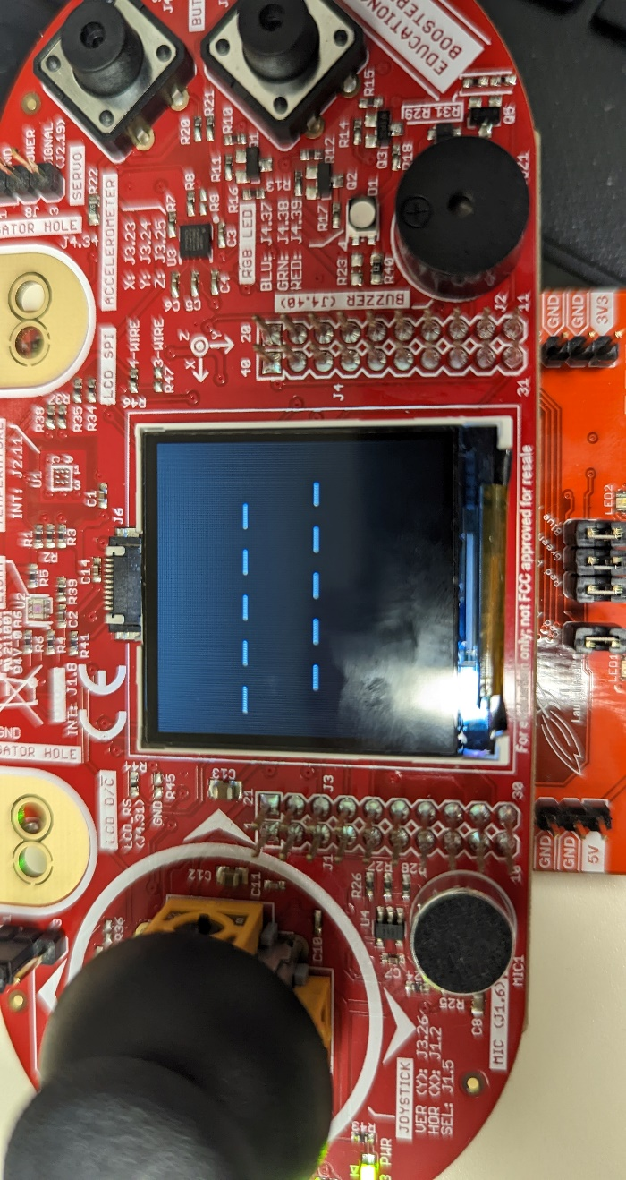**Screenshots**

There are 6 outputs, among which all are square waveform. So, we are adding only one screenshots photo.